Bangladesh Medical Association (BMA)
List of Life Member-93
08. BMA Chandpur Branch

Sl No | Voter No | Voter Details
1 | Voter No  LM-0800001  No Image | DR. NOORUR RAHMAN  F/Name:  M/Name:  BM & DC Reg. No:  NID:  Cell:  Address: Chandpur  Blood Group:  E X P I R E D
2 | Voter No  LM-0800002  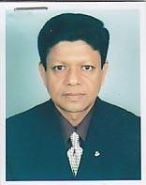 | DR. MD. A.Q. RUHUL AMIN  F/Name:  M/Name:  BM & DC Reg. No:  NID:  Cell:  Address: M/S Comilla Pharmacy New Market, Nutan Bazar, Chandpur.  Blood Group:
3 | Voter No  LM-0800003  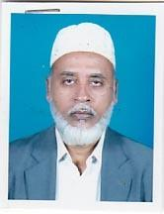 | DR. MD. ANWAR HOSSAIN SHAIKH  F/Name:  M/Name:  BM & DC Reg. No:  NID:  Cell:  Address: Surgeon Mazharul Haque BNSB Eye Hospital Chandpur  Blood Group:
4 | Voter No  LM-0800004  No Image | DR. MD. ABDUL MANNAN MIA  F/Name:  M/Name:  BM & DC Reg. No:  NID:  Cell:  Address: Sayeda Pharmacy Bogadi Road Natun Bazar, Chandpur  Blood Group:
5 | Voter No  LM-0800005  No Image | DR. MD. GOLAM FARUQUE BHIYAN  F/Name:  M/Name:  BM & DC Reg. No:  NID:  Cell:  Address: Medical Officer District Hospital, Chandpur.  Blood Group:
6 | Voter No  LM-0800006  No Image | DR. FATIMA AKHTER  F/Name:  M/Name:  BM & DC Reg. No:  NID:  Cell:  Address: Medical Officer (MCH-FP) Matlab, Chandpur.  Blood Group:
7 | Voter No  LM-0800007  No Image | DR. MUHAMMAD SHAH NAWAZ  F/Name:  M/Name:  BM & DC Reg. No:  NID:  Cell:  Address: TH & FPO Matlab, Chandpur.  Blood Group:
8 | Voter No  LM-0800008  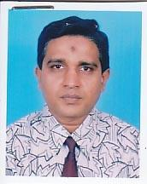 | DR. MUKIT SHOFIUL ALAM  F/Name:  M/Name:  BM & DC Reg. No:  NID:  Cell:  Address: Chami Nibash Kadamtala, Chandpur.  Blood Group:
9 | Voter No  LM-0800009  No Image | DR. S.M. SHAHIDULLAH  F/Name:  M/Name:  BM & DC Reg. No:  NID:  Cell:  Address: Alimpur, Chandpur.  Blood Group:
10 | Voter No  LM-0800010  No Image | DR. MD. ZAMIR AHMED  F/Name:  M/Name:  BM & DC Reg. No:  NID:  Cell:  Address: 232, Railway Howker Market, Chandpur.  Blood Group:
11 | Voter No  LM-0800011  No Image | DR. A.S.S. MAHMOOD  F/Name:  M/Name:  BM & DC Reg. No:  NID:  Cell:  Address: Junior Consultant Sadar Hospital, Chandpur.  Blood Group:
12 | Voter No  LM-0800012  No Image | DR. SABRINA SULTANA  F/Name:  M/Name:  BM & DC Reg. No:  NID:  Cell:  Address: Chandpur.  Blood Group:  TRANSFERED to BMA Dhaka City  LM-1405543
13 | Voter No  LM-0800013  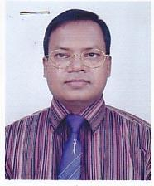 | DR. M.A. GAFUR MIAH  F/Name:  M/Name:  BM & DC Reg. No:  NID:  Cell:  Address: Family Planing Officer, Solaghar Sadar Hospital, Chandpur  Blood Group:
14 | Voter No  LM-0800014  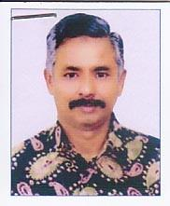 | DR. SYED MD. NURUL HUDA  F/Name:  M/Name:  BM & DC Reg. No:  NID:  Cell:  Address: General Hospital Stadium Road, Chandpur.  Blood Group:
15 | Voter No  LM-0800015  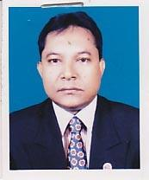 | DR. KAZI MUSTAFA SARWAR  F/Name:  M/Name:  BM & DC Reg. No:  NID:  Cell:  Address: Junior Consultant T.B. Clinic, Chandpur.  Blood Group:
16 | Voter No  LM-0800016  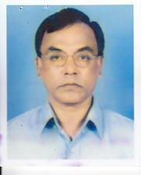 | DR. MD. NURUL ISLAM  F/Name:  M/Name:  BM & DC Reg. No:  NID:  Cell:  Address: Health Complex Matlab, Chandpur.  Blood Group:
17 | Voter No  LM-0800017 | DR. MD. MAYNUL ISLAM  F/Name:  M/Name:  BM & DC Reg. No:  NID:  Cell:  Address: Model Diagnostic Clinic Comilla Road, Chandpur  Blood Group:
18 | Voter No  LM-0800018  No Image | DR. MD. JAHANGIR KHAN  F/Name: Late Nur. Hossain Khan  M/Name:  BM & DC Reg. No: 19032  NID:  Cell:  Address: Vill: Nayekpur, Post: Barati, Thana: Madan, Netrokona  Blood Group:
19 | Voter No  LM-0800019 | DR. MILON KRISNA SARKER  F/Name: Jitendra Chandra Sarker  M/Name: Gita Rani Sarker  BM & DC Reg. No: 25904  NID: 2699040706057  Cell: 01711934647  Address: Consultant (Ortho Surgery), Sadar Hospital, Chandpur  Blood Group: A-
20 | Voter No  LM-0800020 | DR. MD. ABU TAHER  F/Name: Md. Moqsudur Rahman  M/Name: Sofura Begum  BM & DC Reg. No: 10883  NID: 2691649097290  Cell: 01553511958  Address: Shop No: 24, Stadium Market, Chandpur  Blood Group: O+
21 | Voter No  LM-0800021  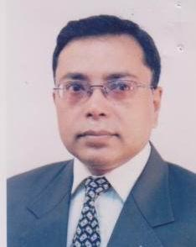 | DR. SUBIR SAHA  F/Name: Sukhen Chandra Saha  M/Name: Chinu Saha  BM & DC Reg. No: 0800021  NID: 1926710065369  Cell: 01711963463  Address: Naura Health Sub Center, Shaharasti, Chandpur  Blood Group: B+
22 | Voter No  LM-0800022  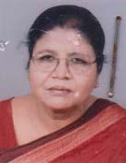 | DR. SYEDA BADRUN NAHAR  F/Name: Syed Darbesh Ali  M/Name: Syeda Shamsun Nahar  BM & DC Reg. No: 3705  NID:  Cell: 01715919790  Address: 7 No. Stadium Road, Chandpur  Blood Group: A+
23 | Voter No  LM-0800023  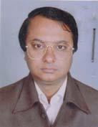 | DR. A.K.M MAHBUBUL ALAM  F/Name: Md. Safiullah  M/Name: Mrs. Shamsunnahar Begum  BM & DC Reg. No: 20828  NID:  Cell: 01712116773  Address: Fulel, Stadium Road, Chandpur  Blood Group: B+
24 | Voter No  LM-0800024  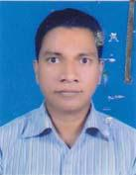 | DR. SUJIT KUMAR DAS  F/Name: Late. Sahadab Chandra Das  M/Name: Sandhya Rani Das  BM & DC Reg. No: 24476  NID: 1322214167410  Cell: 01552321827  Address: Room-205, Sadar Hospital, Chandpur  Blood Group: B+
25 | Voter No  LM-0800025  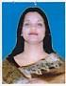 | DR. HAMIMA AKTER  F/Name: Ali Ahmed  M/Name:  BM & DC Reg. No:  NID:  Cell:  Address: Vill-Koraiya, P.O- Kachua, Thana-Kachua, Chandpur.  Blood Group:
26 | Voter No  LM-0800026 | DR. BISWANATH PODDER  F/Name: Ramani Mohan Podder  M/Name: Aruna Rani Podder  BM & DC Reg. No: 15637  NID: 1322207125165  Cell: 01711260790  Address: Apollo Medical Centre, Shahid Muktijuddha Sarak, Chandpur-3600  Blood Group: B+
27 | Voter No  LM-0800027  No Image | DR, SHAH ALI AKBAR ASHRAF  F/Name:  M/Name:  BM & DC Reg. No:  NID:  Cell:  Address: Sadar Hospital, Chandpur.  Blood Group:
28 | Voter No  LM-0800028  No Image | DR. J M. KAMRUL ISLAM  F/Name: Mr. S.A. Jabbar  M/Name:  BM & DC Reg. No:  NID:  Cell:  Address: Chandpur  Blood Group: n_a
29 | Voter No  LM-0800029  No Image | DR. FATEMA BEGUM  F/Name: Late: Abdus Sattar Mian  M/Name:  BM & DC Reg. No:  NID:  Cell:  Address: Chandpur  Blood Group: n_a
30 | Voter No  LM-0800030 | DR. SHAFIQUL ISLAM  F/Name: Late. Sayed Ali Bakaul  M/Name: Late. Sharepa Khatoon  BM & DC Reg. No: 23184  NID: 1322207125479  Cell: 01913370767  Address: Doctors Quarter (1st Floor-Koral), Strand Road, 250 Bedded Gen. Hospital, Chandpur  Blood Group: A+
31 | Voter No  LM-0800031  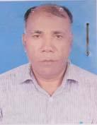 | DR. M.A MANNAN  F/Name: Late. Abdul Aziz Bepari  M/Name: Mrs. Dub Meher  BM & DC Reg. No: 8322  NID: 1317911374208  Cell: 01716640717  Address: UHFDO, Matlab CAD, Chandpur  Blood Group: B+
32 | Voter No  LM-0800032  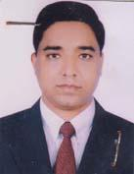 | DR. MD. MIZANUR RAHMAN KHAN  F/Name: Late. Md. Anowar Hossain Khan  M/Name: Rajia Begum  BM & DC Reg. No: 29997  NID:  Cell: 01713413969  Address: Nova Aid, Mission Road, Chandpur-3600  Blood Group: O+
33 | Voter No  LM-0800033  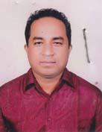 | DR. MOHAMMAD HARUN OR RASHID  F/Name: Mohammad Kalim Ullah  M/Name: Mrs. Lutfa Kalim  BM & DC Reg. No: 32398  NID:  Cell: 01819135715  Address: Midland Hospital, Chandpur  Blood Group: B+
34 | Voter No  LM-0800034 | DR. TAHEDUL ISLAM PATWARY  F/Name: Md. Tafazzal Hossain Patwary  M/Name: Monowara Begum  BM & DC Reg. No: 58842  NID: 1312294196741  Cell: 01919445806  Address: Patwary Bari, South Gunrajeli, P.O: Notun Bazar, PS: Chandpur Sadar, Dist: Chandpur  Blood Group: O+
35 | Voter No  LM-0800035 | DR. MOBAREK HOSSAIN CHOWDHURY  F/Name: Late. Altaf Hossain Chowdhury  M/Name: Late. Momena Begum  BM & DC Reg. No: 26528  NID: 1322210142153  Cell: 01715691850  Address: Alimpara, Hazi Mohsin Road, Chandpur  Blood Group: O+
36 | Voter No  LM-0800036  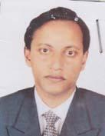 | DR. MOHAMMAD JAHANGIR ALAM (SHIPON)  F/Name: Late. Mohammad Abul Farha  M/Name: Mrs. Ayesha Farha  BM & DC Reg. No: 27034  NID: 1322207125482  Cell: 01741005129  Address: Anaesthesist, 250 Bedded General Hospital, Chandpur-3600  Blood Group: O+
37 | Voter No  LM-0800037  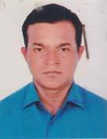 | DR. MD. ELEUS  F/Name: Md. Rustomali Sarder  M/Name: Mrs. Jebunnessa Begum  BM & DC Reg. No: 17844  NID: 1312294199338  Cell: 01711477752  Address: Medical Officer (MCH.FP), Sadar, Chandpur  Blood Group: A-
38 | Voter No  LM-0800038  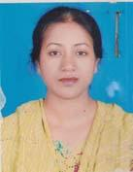 | DR. SABERA ISLAM  F/Name: Md. Rafiqul Islam  M/Name: Mrs. Shamsun Nahar  BM & DC Reg. No: 24411  NID: 1312294199337  Cell: 01712571539  Address: MCWC Quarter, Mother & Child Welfare Centre, Chandpur  Blood Group: O+
39 | Voter No  LM-0800039  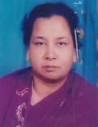 | DR. FATEMA KHATUN  F/Name: Md. Tafazzal Hossain  M/Name: Mohsena Begum Patwary  BM & DC Reg. No: 14362  NID: 1322210141572  Cell:  Address: 124, Alimpara, Chandpur  Blood Group: A+
40 | Voter No  LM-0800040  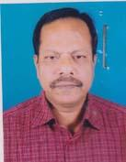 | DR. MD. SERAJUL ISLAM  F/Name: Late. Afsar Uddin Mia  M/Name: Late. Golenur Begum  BM & DC Reg. No: 12391  NID: 1322207125561  Cell: 01712169580  Address: RMO, 250 Bedded General Hospital, Chandpur  Blood Group: B+
41 | Voter No  LM-0800041  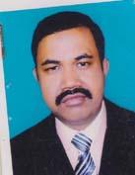 | DR. MD MUSA  F/Name: Abdne Mozid Bakaul  M/Name: Moriom Begum  BM & DC Reg. No: 43918  NID:  Cell: 01712842444  Address: Alimpara, Chandury Bari, Hazi Mohsin Road, Chandpur  Blood Group:
42 | Voter No  LM-0800042 | DR. MANOJ KANTI MAZUMDER  F/Name: Late. Srikanta Mazumder  M/Name: Late. Kushum Kumari Mazumder  BM & DC Reg. No: 11856  NID: 1322214166358  Cell: 01817452893  Address: 101 Mission Para, Mission Road, Chandpur  Blood Group: O+
43 | Voter No  LM-0800043  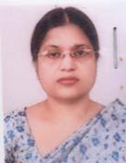 | DR. MINU RANI SARKER  F/Name: Late. Birendra Kishor Sarker  M/Name: Late. Shuvodra Sarker  BM & DC Reg. No: 19346  NID: 1322214166357  Cell: 01819130658  Address: 101 Mission Para, Mission Road, Chandpur  Blood Group: B+
44 | Voter No  LM-0800044  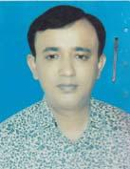 | DR. ABUL KALAM AZAD  F/Name: Md. Abdul Mannan Shake  M/Name: Roshida Begum  BM & DC Reg. No: 44624  NID: 1314553765661  Cell: 01711373110  Address: Azad Medical And Diagnostic Centre, Rupsha Bazar, Faridgonj, Chandpur  Blood Group: O+
45 | Voter No  LM-0800045  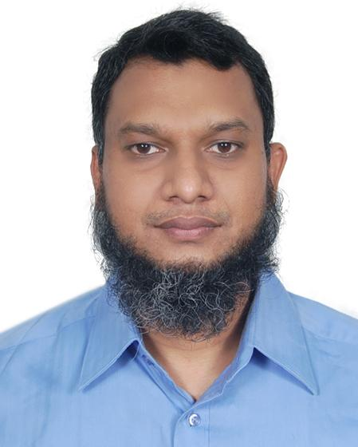 | DR. MD. NOMAN HOSSAIN  F/Name: Md. Majibur Rahman  M/Name: Mrs. Noorjahan Talukder  BM & DC Reg. No: 40305  NID: 1312285345233  Cell: 01717769901  Address: Shoibal, 2nd Floor, Doctors Quarter, 250 Bedded General Hospital, Chandpur  Blood Group: A+
46 | Voter No  LM-0800046  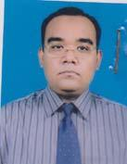 | DR. MD. RAFIQUL HASAN FAISAL  F/Name: Late. Faruque Ahmed  M/Name: Ainun Nahar  BM & DC Reg. No: 38027  NID: 2690246028729  Cell: 01714046149  Address: Anaya, Mission Road, Chandpur  Blood Group: A+
47 | Voter No  LM-0800047  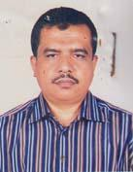 | DR. MD. WALIUR RAHMAN MAJUMDER  F/Name: Md. Shamsul Huda  M/Name: Mrs. Nilufa Begum  BM & DC Reg. No: 15250  NID: 1322207122875  Cell: 01711704540  Address: Consultant (Paediatrics), 250 Beded General Hospital, Chandpur  Blood Group: A+
48 | Voter No  LM-0800048  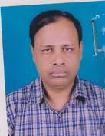 | DR. SALEH AHMED  F/Name: Ali Ahmed Miah  M/Name: Mansura Khatun  BM & DC Reg. No: 19002  NID: 1315813567550  Cell: 01731190278  Address: Sr. Consultant, Medical, 250 Bedded General Hospital, Chandpur  Blood Group: O+
49 | Voter No  LM-0800049  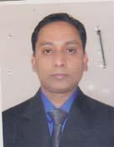 | DR. MD. ANWARUL ABEDIN  F/Name: Md. Zainal Abedin  M/Name: Azizun Nessa  BM & DC Reg. No: 26408  NID: 1322214165912  Cell: 01713-464289  Address: Abedin Sonography, Mission Road, Chandpur  Blood Group:
50 | Voter No  LM-0800050  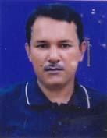 | DR. MD. DELWAR HOSSAIN BHUIYAN  F/Name: Md. Hafiz Uddin Bhuiyan  M/Name: Mrs. Delwara Khanom  BM & DC Reg. No: 27900  NID: 1322211150470  Cell: 01819131306  Address: City-Aid-Diagnostic Centre, Notun Bazar, Chandpur  Blood Group: B+
51 | Voter No  LM-0800051 | DR. MAHMUDUN NABI MASUM  F/Name: M.a Quddus  M/Name: Asma Akter  BM & DC Reg. No: 37564  NID:  Cell: 01717647997  Address: 29, Aparajita, Guakhola Road, Chandpur  Blood Group: O+
52 | Voter No  LM-0800052  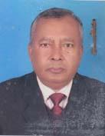 | DR. PARESH CHANDRA PAUL  F/Name: Late. Mukunda Kumar Paul  M/Name: Santi Sukumar Paul  BM & DC Reg. No: 8352  NID: 1324508932746  Cell: 01713101459  Address: Palash Villa, Hospital Road, Faridgonj, P.O & PS: Faridgonj, Dist: Chandpur  Blood Group: B+
53 | Voter No  LM-0800053  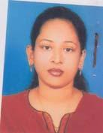 | DR. FATEMA SHAHID  F/Name: Md. Sohidullah  M/Name: Khadiza Sharif  BM & DC Reg. No: 55909  NID:  Cell: 01925241472  Address: UHC, Faridgonj, Chandpur  Blood Group: O+
54 | Voter No  LM-0800054  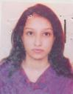 | DR. TANIA ALAM  F/Name: Late. Nurul Alam  M/Name: Mrs. Asma Alam  BM & DC Reg. No: 47786  NID:  Cell: 01816284019  Address: UHC, Faridgonj, Chandpur  Blood Group: O+
55 | Voter No  LM-0800055  No Image | DR. SYED MD. IDRIS ALI  F/Name:  M/Name:  BM & DC Reg. No:  NID:  Cell:  Address: Senior Concultant,Ortha. Surgery, Sadar Hospital, Chandpur.  Blood Group:
56 | Voter No  LM-0800056 | DR. A. K. M. MAHABUBUR RAHMAN  F/Name: Md. Ayub Ali Sarker  M/Name: Mrs. Wahida Begum  BM & DC Reg. No: 33140  NID: 1327604067955  Cell: 01711190263  Address: Padma-1, Doctors Quarter, Matlab South, Upazilla Health Complex, Chandpur  Blood Group: O+
57 | Voter No  LM-0800057 | DR. ROWSHABA NASRIN  F/Name: Sk. Ruhul Amin  M/Name: Noor Mahal Begum  BM & DC Reg. No: 42996  NID: 2696402501094  Cell: 01712664333  Address: Midland Hospital, Alim Para, Chandpur  Blood Group: AB+
58 | Voter No  LM-0800058  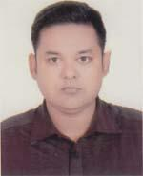 | DR. MD. SHAFIQUL ISLAM (RONY)  F/Name: Shamsuddin Ahmed  M/Name: Sufia Ahmed  BM & DC Reg. No: 49066  NID: 2694814912426  Cell: 01711908514  Address: 7th Floor, Belleyue Hospital, Chandpur Sadar, Chandpur  Blood Group: A+
59 | Voter No  LM-0800059 | DR. MOHAMMAD KHABIR UDDIN  F/Name: Late Md. Abul Hossain  M/Name: Forida Begum  BM & DC Reg. No: 51684  NID: 1317915223527  Cell: 01731238955  Address: 0586, GT Road Chairman Ghvit, Shologhor, Chandpur  Blood Group: A+
60 | Voter No  LM-0800060 | DR. FARID AHMED CHOUDHURY  F/Name: Fayez Ullah Choudhury  M/Name: Rehana Akhter  BM & DC Reg. No: 50479  NID: 9196212239704  Cell: 01712659399  Address: Karim Patwary Road, Taltola, Chandpur  Blood Group: O+
61 | Voter No  LM-0800061  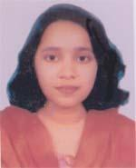 | DR. TAHERA AKHTER  F/Name: Md. Saif Uddin  M/Name: Selina Akhter  BM & DC Reg. No: 49249  NID: 1594116382585  Cell: 01780809094  Address: Dilara Manzil, Bagadi Road, Natun Bazar, Chandpur  Blood Group: A+
62 | Voter No  LM-0800062 | DR.MD. GOLAM KAWSAR  F/Name: Mominul Haque Patwary  M/Name: Dilara Begum  BM & DC Reg. No: 41239  NID: 1322211150206  Cell: 01711058157  Address: Dilara Manzil, Bagadi Road, Natun Bazar, Chandpur  Blood Group: B+
63 | Voter No  LM-0800063  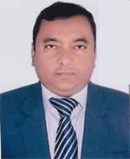 | DR. MD. JAKIR HOSSAIN  F/Name: Alhajj Md. Sakayet Hossain Master  M/Name: Setara Begum  BM & DC Reg. No: 20759  NID: 1322215168820  Cell: 01715026128  Address: BNSB, Consultant, Eye Hospital, Chandpur  Blood Group: O+
64 | Voter No  LM-0800064 | DR. BIPLOB DAS  F/Name: Biraja Gopal Das  M/Name: Manju Rani Das  BM & DC Reg. No: 43916  NID: 2699038638133  Cell: N/A  Address: Chandpur Sadar, Chandpur  Blood Group: O+
65 | Voter No  LM-0800065 | DR. MOHAMMAD MUIN UDDIN  F/Name: Mohammad Lutfer Rahman  M/Name: Saydun Nessa  BM & DC Reg. No: 24676  NID: 2699040699319  Cell: 01711907392  Address: 250 Beded General Hospital, Chandpur  Blood Group: A+
66 | Voter No  LM-0800066  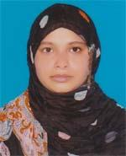 | DR. TABENDA AKTER  F/Name: Fariduddin Mohammad Akbar  M/Name: Gulshan Ara Farid  BM & DC Reg. No: 40876  NID: 2694814922850  Cell: 01716285061  Address: Consultan (Obs & Gynae), 250 Beded General Hospital, Chandpur  Blood Group: O+
67 | Voter No  LM-0800067 | DR. KHALED HASAN  F/Name: Md. Monsiuddin  M/Name: Khaleda Begum  BM & DC Reg. No: 62353  NID: 0695111185327  Cell: 01710590670  Address: 2B, Kabir Tower, Faridgonj, Chandpur  Blood Group: O+
68 | Voter No  LM-0800068  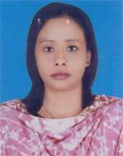 | DR. LIPIKA RANI PAUL  F/Name: Poresh Chandra Paul  M/Name: Ranju Rani Paul  BM & DC Reg. No: 55283  NID: 19811324508855248  Cell: 01777007575  Address: Post+P.s-Faridgonj, Dist-Chandpur  Blood Group: n_a
69 | Voter No  LM-0800069  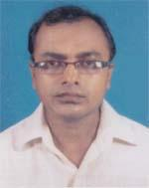 | DR. MD. ABDUL AZIZ MIA  F/Name: Md. Ershad Mia  M/Name: Rabeya Basri  BM & DC Reg. No: 37627  NID: 1314577959057  Cell: 01816934156  Address: UHC, Faridgonj, Chandpur  Blood Group: A+
70 | Voter No  LM-0800070 | DR. SHAH MD. IFTE KHAIRUL ALAM  F/Name: Md. Abdul Quddus  M/Name: Baneya Aktar  BM & DC Reg. No: 51986  NID: 1322207121583  Cell: 01684348494  Address: Maternite Road South, Chandpur Sadar, Chandpur  Blood Group: B+
71 | Voter No  LM-0800071 | DR. ABU SALEH MD. SIRAJUN MUNIR  F/Name: Md. Aminul Haque Miah  M/Name: Firoza Haque  BM & DC Reg. No: 34379  NID: 19762695051180495  Cell: 01715022162  Address: Jun. Consultant (Medicine) 250 Bed General Hospital, Chandpur  Blood Group: AB+
72 | Voter No  LM-0800072  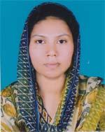 | DR. NUSRAT JAHAN  F/Name: Md. Abdul Haque Patwary  M/Name: Mrs. Hasina Begum  BM & DC Reg. No: 46668  NID: 19741322212154926  Cell: 01814342743  Address: Nusrat Monjil, Bisnodi H/o No. 0498, Ward -15, Comilla Road, Chandpur  Blood Group: O-
73 | Voter No  LM-0800073  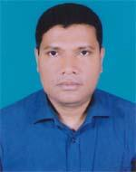 | DR. MD. NAZRUL ISLAM  F/Name: Late Hafez Moshiur Rahman  M/Name: Mrs. Amirun Nessa  BM & DC Reg. No: 37399  NID: 19741322212154925  Cell: 01818567230  Address: Nusrat Monjil Bisnodi H/d No. 0498, 15 No. Ward, Kadar Mizi Road , Chandpur  Blood Group: A+
74 | Voter No  LM-0800074  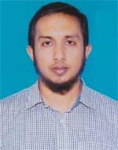 | DR. AHSAN ULLAH RUMI  F/Name: A. B. M. Wali Ullah  M/Name: Dil Afroz Begum  BM & DC Reg. No: 40658  NID: 2694814922848  Cell: 01747721742  Address: 979, Pir Badsha Mia Road, Professor para, Chandpur  Blood Group: B+
75 | Voter No  LM-0800075  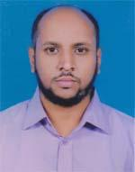 | DR. RAIHAN MUHAMMAD OMAR FARUQ  F/Name: Md. Abdul Jabbar  M/Name: Ajmala Begum  BM & DC Reg. No: 45352  NID: 9116290503131  Cell: 01711484996  Address: 0017/Moniher, Stadium Road, Post-Chandpur, Thana-Chandpur Sadar, Dist-Chandpur  Blood Group: B+
76 | Voter No  LM-0800076  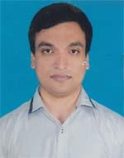 | DR.KHALED JAHAN FAHIM  F/Name: Md. Jahangir Kabir  M/Name: Khaleda Afroz  BM & DC Reg. No: 55416  NID: 2617272896447  Cell: 01716838567  Address: Boishakhi Villa, Mohila College Road, Chandpur Sadar, Chandpur  Blood Group: B+
77 | Voter No  LM-0800077 | DR. MUHAMMAD SHAHADAT HOSSAIN  F/Name: Muhammad Abdur Rezzaque  M/Name: Zaheda Khatun  BM & DC Reg. No: 32114  NID: 19752693625853128  Cell: 01716681087  Address: 250 Bedded General Hospital, Orthopaetric Dept. Chandpur  Blood Group: A+
78 | Voter No  LM-0800078  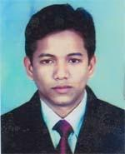 | DR. MD. MAHIBUR RAHMAN  F/Name: Md. Shafiqur Rahman  M/Name: Nishat Fatema Zinnat  BM & DC Reg. No: 45703  NID: 9196212243397  Cell: 01711041213  Address: Gosh Para, Kaladi, Matlab South, Chandpur  Blood Group: A+
79 | Voter No  LM-0800079 | DR. AOLADUZZAMAN SOURAV  F/Name: Iqbaluzzaman Faruk  M/Name: Rashida Aktar  BM & DC Reg. No: 59808  NID: 1324906415709  Cell: 01818249384  Address: Upazilla Health Complex, Hajigonj, Chandpur  Blood Group: O+
80 | Voter No  LM-0800080 | DR. MD. ARIFUL ISLAM  F/Name: Md. Abdus Sattar  M/Name: Mst. Anjuman Ara Begum  BM & DC Reg. No: 39993  NID: 19801324906415387  Cell: 01750817181  Address: Vip Hospital & Digital Diagnostic Lab, Hajigonj, Chandpur  Blood Group: O+
81 | Voter No  LM-0800081 | DR. MUHAMMAD MINHAZUR RAHMAN  F/Name: Md. Abdul Latif  M/Name: Rehana Akter  BM & DC Reg. No: 50155  NID: 9196203121214  Cell: 01818384990  Address: H-South Sidi of Thana, Post+P.s-Hajigonj, Dist-Chandpur  Blood Group: O+
82 | Voter No  LM-0800082  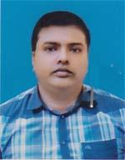 | DR. A. M. WASIQ FAISAL  F/Name: Prof. Md. Wazed Ali Akanda  M/Name: Mrs. Shahina Begum  BM & DC Reg. No: 51344  NID: 2694263700029  Cell: 01937000777  Address: Shah Miran Hospital and Diagonostic Lab, Hajigonj East Bazar, Hajigonj, Chandpur  Blood Group: O+
83 | Voter No  LM-0800083  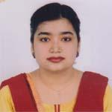 | DR. TANZINA RAHMAN  F/Name: Mohammad Lutfor Rahman Talukder  M/Name: Mrs. Anjumand Banu  BM & DC Reg. No: 52394  NID: 9329514302926  Cell: 01744262666  Address: Shah Mirah Hospital and Diagnostic Lab, Hajigonj East Bazar, Hajigonj, Chandpur  Blood Group: A+
84 | Voter No  LM-0800084  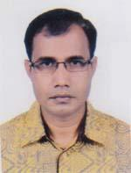 | DR. MUHAMMAD SAIFUL ISLAM  F/Name: Md. Hasnat Ali  M/Name: Julekha Begum  BM & DC Reg. No: 40035  NID: 1324905413232  Cell: 01716064144  Address: Upazilla Health Complex, Hazigonj, Chandpur  Blood Group: B+
85 | Voter No  LM-0800085 | DR. MOHAMMAD MOHIBUL ALAM  F/Name: Mohammad Abdus Sobhan  M/Name: Masuma Khanam  BM & DC Reg. No: 61204  NID: 9196201102294  Cell: 01722455440  Address: Upazilla Health Complex, Hajigonj, Chandpur  Blood Group: B+
86 | Voter No  LM-0800086 | DR. A. H. M SUJAUDDAULA  F/Name: Md. Hossain Talukdar  M/Name: Mrs. Sajeda Begum  BM & DC Reg. No: 42451  NID: 19781322212154764  Cell: 01711355988  Address: GM Tower, (8th Floor) Comilla Road, Chandpur  Blood Group: B+
87 | Voter No  LM-0800087  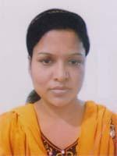 | DR. SAJEDA BEGUM  F/Name: Md. Hanif Bhuyian  M/Name: Mrs. Jharna Begum  BM & DC Reg. No: 44212  NID: 1322212154746  Cell: 01711943822  Address: GM Tower, 8th Floor, Comilla Road, Chandpur  Blood Group: O+
88 | Voter No  LM-0800088  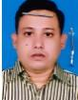 | DR. ABU SADAT MOHAMMAD SAYEM  F/Name: Late Nur Mohammad Faraji  M/Name: Rehana Begum  BM & DC Reg. No: 42997  NID: 2696402501093  Cell: 01711221172  Address: Shaibal, Doctors quater, 250 Beded General Hospital, Chandpur  Blood Group: B+
89 | Voter No  LM-0800089  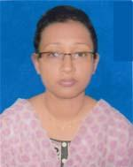 | DR. AZMERA BEGUM  F/Name: Ali Ahmed  M/Name: Jahanara Begum  BM & DC Reg. No: 55170  NID: 19861322215168798  Cell: 01747665452  Address: Doctors quarter , Probal 3rd Floor, 250 General Hospital, Chandpur  Blood Group: B+
90 | Voter No  LM-0800090 | DR. MAHBUB ALI KHAN  F/Name: Md. Abdur Rahman  M/Name: Monjuma Begum  BM & DC Reg. No: 51975  NID: 9196213253060  Cell: 01714610224  Address: Vill-Hamankordi, Post-Shatali, P.s-Chandpur Sadar, Dist-Chandpur  Blood Group: O+
91 | Voter No  LM-0800091 | DR. H. M. MAHBUB  F/Name: Md. Belayet Hossain  M/Name: Mrs. Parvin Hossain  BM & DC Reg. No: 37053  NID: 1324905600180  Cell: 01720098870  Address: VIP Hospital, Torgor, Hazigonj, Chandpur  Blood Group: B+
92 | Voter No  LM-0800092 | DR. IFFAT ARA RAHMAN  F/Name: Md. Bazlur Rahman Bhuiyan  M/Name: Mrs. Monira Rahman  BM & DC Reg. No: 64458  NID: 1324905600174  Cell: 01772515758  Address: VIP, Hospital, Toragor, Hazigonj, Chandpur  Blood Group: A+
93 | Voter No  LM-0800093  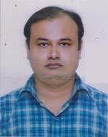 | DR. A. B. M. SHAFIQUR RAHMAN  F/Name: Siddiqur Rahman  M/Name: Sayera Begum  BM & DC Reg. No: 43593  NID: 19811314513000014  Cell: 01714107670  Address: Asst. Registrar (Ortho Surgery), 250 Beded General Hospital, Chandpur  Blood Group: O+

